2.7 Measure ground level, deviation angles and compass bearing

Linear measurement

Measurement having only one dimension
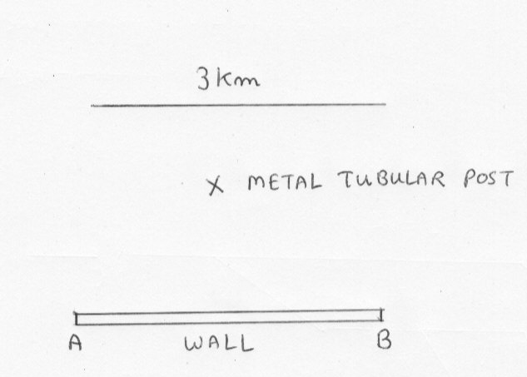

Angular measurement

The measurement of the angles formed when two straight lines meet.
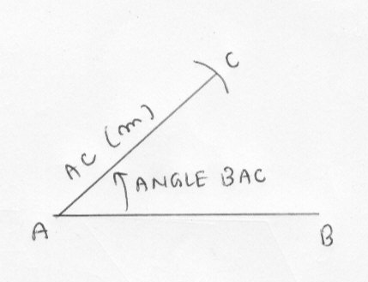

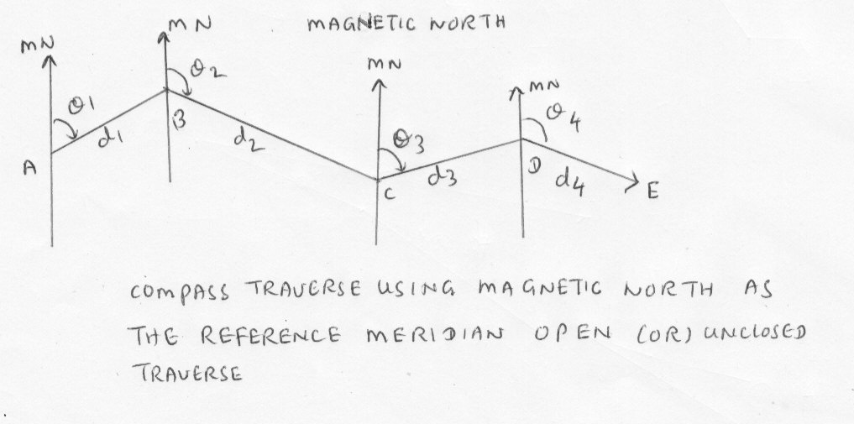

Site surveying and levelling

Scale of map

1;25000---- Small scale map.
- Planning large scale engineering works involving gradient of roads, sewers , pipes
- Involve with the flow of rivers, street
- When contour lines provide a means of solving problems intervisibility and clearance between points
- To illustrate aspects of regional planning

1:10000---Almost accurate drawn to scale. To accommodate road names.

- Estate management, design of schemes for water supply
- Geological surveying
- Town planning

1:2500-----Highly detailed map providing accurate information to fairly large scale

1:1250------ Double management of 1:2500

- All streets are named
- Block plan , location plan when marking application for planning and building regulation approval
- By designers for initial layout.
- By statutory undertakings to record the positions of power lines.

Survey stations

A survey station is a point of importance at the beginning (or) end of a chart (or) at the junction of one line with another.

It is usually marked by an insertion into the ground of a vertical ranging pole. On the surface , this point may be marked by a stud. Stations should be placed as may be found convenient at the corner of area (or) at prominent points so that the lines joining them are as close as possible.

The base line

This is normally the longest of the chain line forming the pattern of triangle. It should , if possible be laid off on level ground through the center of the site and encompass the whole length of the area. A compass bearing should be taken to fix its direction which in turn will fix the direction of all other lines and allow the position of north to be determined. All survey drawings require a drawn north point.

Survey equipments

Chain

Typical chain pattern The tags shown are for 20 m chain and may be of brass or plastics. Plastics tag may be attached at each whole metre positions with a different colour used at each 5 m position. This is usual for chains longer than 20 m.

Tapes

A tape is used for taking subsidiary measurements in the field. It is suitable for taking off sets which are measurements taken from and at right angles to the chain line or to fix adjacent points as on a boundary.

Laying down the chain

The leader equipped with his ten arrow drags the chain until he is brought up by a gradual pull and directed into line by the followers. Once alignment effected , an arrow is inserted which marks the measurement of one length , care must be taken to ensure that arrows are inserted vertically and the side of vertical handle so that no error equally to the thickness of arrow or the thickness of the handle is in trouble.

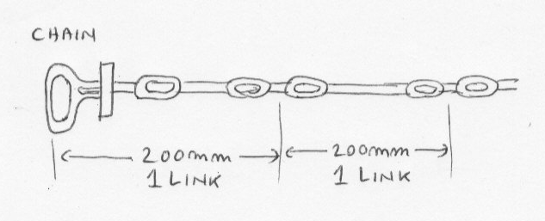
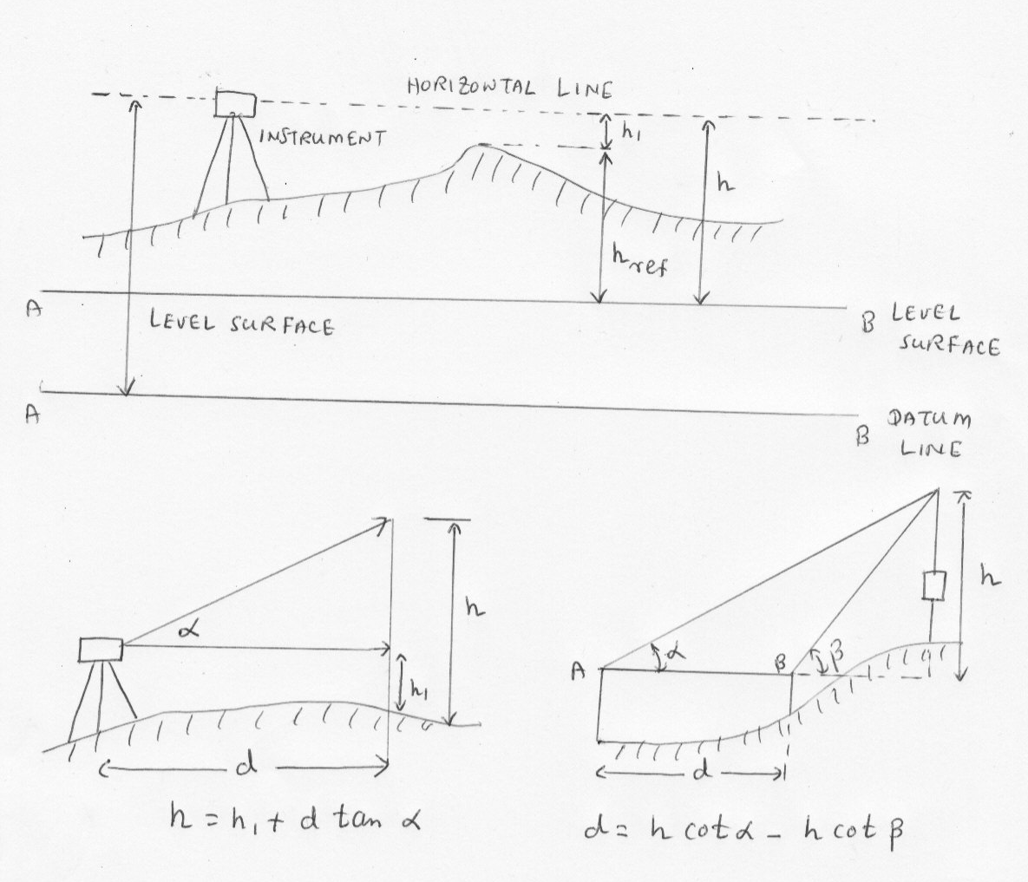
On hilly ground

Very often , due to undulations of some size, the last station point can not be seen, the first , yet intermediate poles must be positioned for lining in the chain man.

The difficulty may be resolved by tying two poles together although this is not very accurate or satisfactory, two other methods may be adopted as follows.

Prism in Theodolite

To see pole

Clinometer

To measure height

Required drawing equipments

Long steel straight edge parallel ruler, protractor 360 degree. French curve, Offset scale

2.8 Perform basic survey of short distribution line , extension to produce field notes

Surveying software

Read the article

“ Re- engineering the Transmission Line Design Design Process in 2.8 Perform basic survey of short distribution line extension to produce field notes handout.
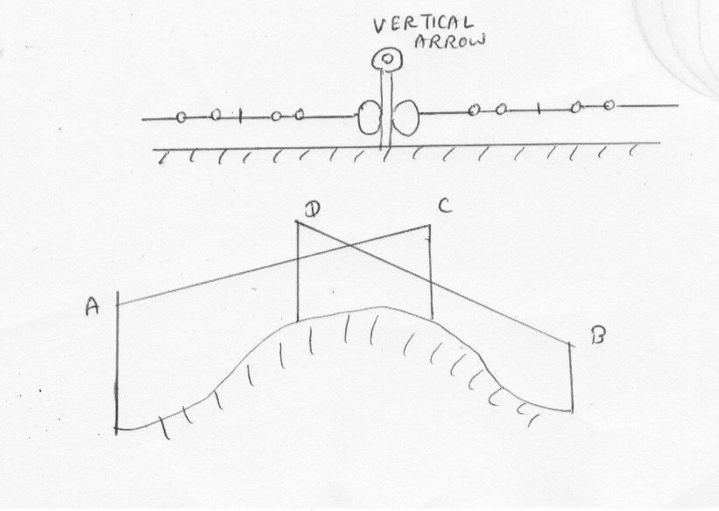

2.8 Site Surveying

Surveying Meanings

Level Datum—It is the level line or surface that has been given to a value to which the heights of points above or below can be referred.

Reduced Level (RL)—It is a value given to a point or surface that represents its height above or below , an assumed level datum.

Bench Mark- Bench Marks are the points that have a reduced level value.

Back Sight--- Back sight is the first reading taken from any instrument set up. It is always taken to a point which has a known RL

Fore Sight – It is the last reading taken from an instrument set up . It is taken to a point where RL is known or where RL is required for further levelling.

Intermediate Sight—It is any other reading taken from an instrument set up.

Change Point—It is a point where RL may not be required but is used in series levelling so that the levelling process can be proceeded.

Inverted Level-- It refers to the bottom inside RL of a pipe

Temporary Bench Mark (TBM)—It is a location normally transferred from a bench mark as a convenient location for other heights to be noted or positioned. For example, they may be positioned close to a building being erected.

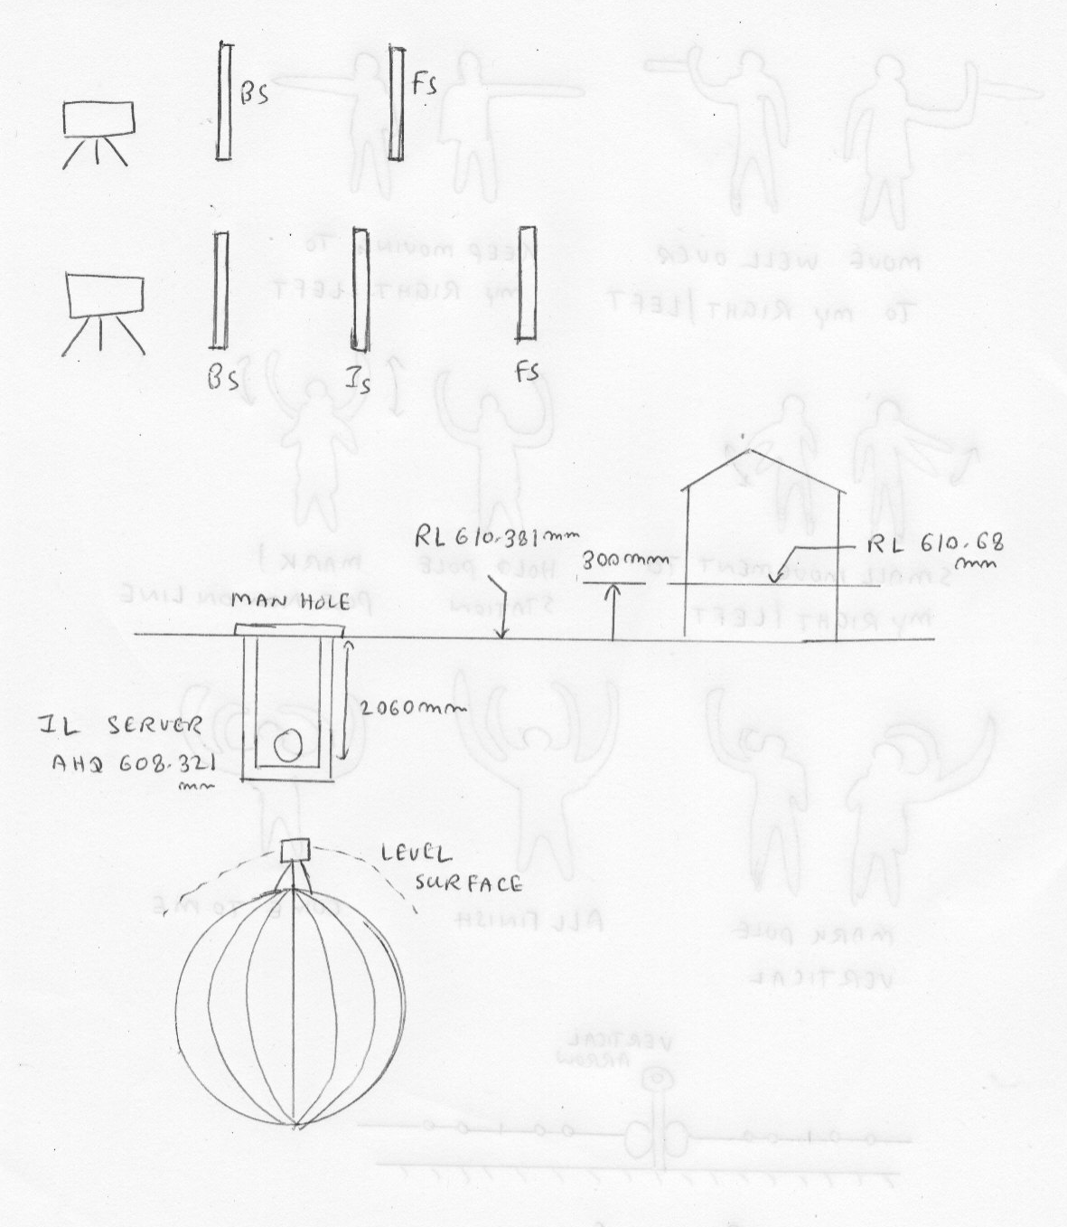
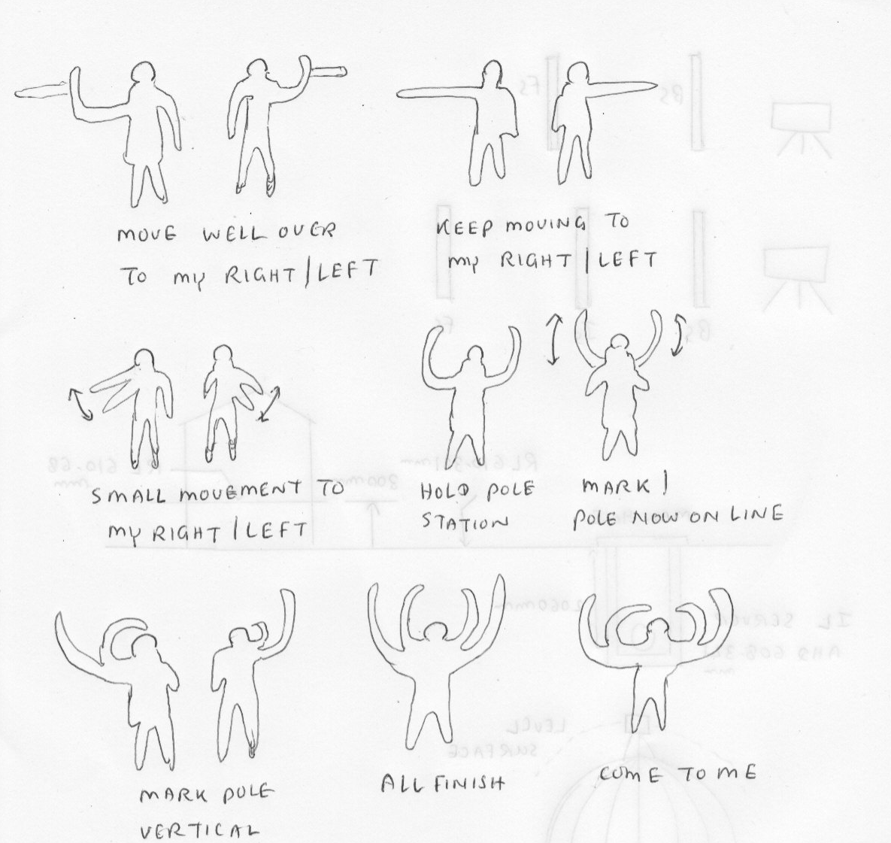
Determination of height difference between two points

Reading |  | Difference Height
Station 1 | Station 2
0.812 | 1.013 | 0.201
0.566 | 0.764 | 0.198
 | ADD The Difference | 0.399
 | Average--- / 2 | 0.195

Rise and fall calculation

FALL
- Second point value is bigger than first point--------- FALL

RISE

- Second point value is smaller than first point---------RISE

Calculation of reduced level from known point by field surveying

(1) 1.325 BS A (PSM)

(2) Fall 1.625 / 4.75 (FS)

(6) 0.596 Rise 2.78

(3) 0.9 (BS)

(5) 3.375 BS

(3a) I S = 1.875

(4) FS 0.25 Rise 1.625

Back sight | Intermediate | Fore Sight | Rise | Fall | RL | Prism
(1) 1.325 |  |  |  |  | 100 | A
 | (1.a) 2.55 |  |  | 1.225 _ | 98.775 | B
 | (1.b) 3.125  Difference |  |  | 0.575 _ | 98.2 | C
(3) 0.9 |  | (2) 4.75  Difference |  | 1.625 _ | 96.575 | D
 | (3.a) 1.875  Difference |  |  | 0.975 _ | 95.6 | E
(5) 3.375 |  | (4) 0.25  Difference | 1.625 + |  | 97.225 | F
 |  | (6) 0.595  Difference |  | 2.78 + | 100.005 | Closed A
ADD ALL  5.6 |  | ADD ALL  5.595 | ADD ALL  4.405 | ADD ALL  4.4

Rules

- Data Entry Table

Back sight | Intermediate | Fore Sight | Rise | Fall | RL | Prism
(1) 1.325 |  |  |  |  | 100 | A

- Flow Direction of Data Entry

Back Sight

Intermediate Ever start

4 .
I

I
5.

Back Sight Fore Sight

6.
If Second point > First Point----------- FALL
If Second point < First Point------------RISE

7.

BS

FS

8. Calculation of reduced level

First RL – Fall = Second RL

First RL + Rise = Second Level

9. To Adjust

ADD----------- ALL ---------FS -------------BS

RISE

FALL

