4.1 Recall the terminology used in relation to voltage profile

Voltage regulation

The voltage regulation is defined as the percentage rise in voltage at receiving end when full load is thrown off, the sending end voltage is unaltered.

Es - Er
Regulation = ----------------- x 100 %
Er

I R Cos φ _{r} + I X Sin φ _{r}
= ------------------------------
Er
Off load tap changer
Fig 7.1
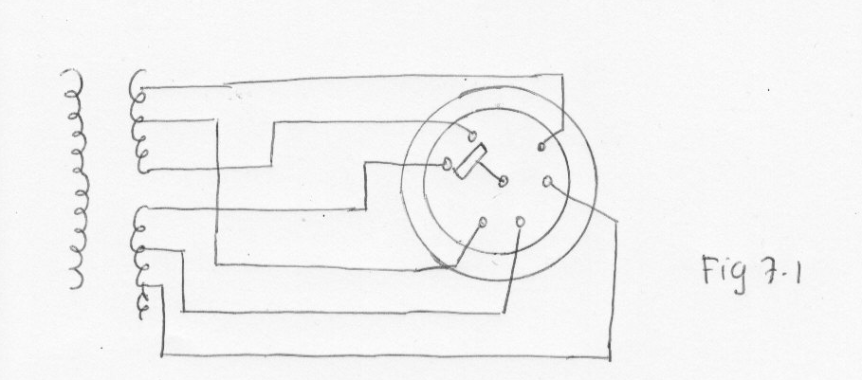

+/- 2 ½ % to +/- 5% of nominal voltage

On load tap changer

Fig 7.2

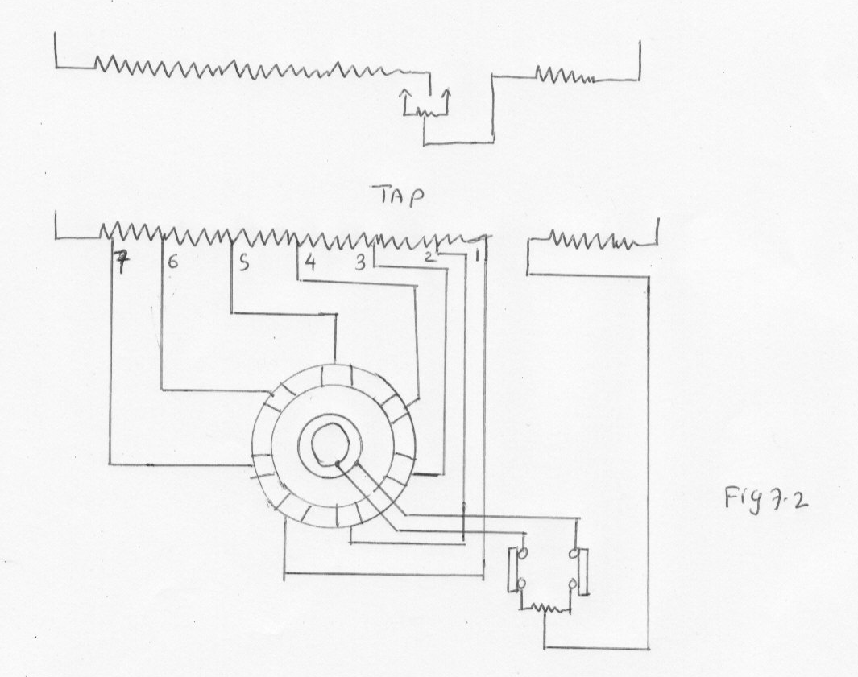
Many transformers are provided with equipments for changing their voltage ratio under load.

Booster transformer

A separate transformer may be used to inject a variable voltage into a circuit for regulating purpose.

Quadrature booster

Injects a voltage with a major component at 90 degree to the existing voltage.

Induction and moving coil regulator

Ф output = Ф 1 + Ф 2 depending on the position of moving coil.

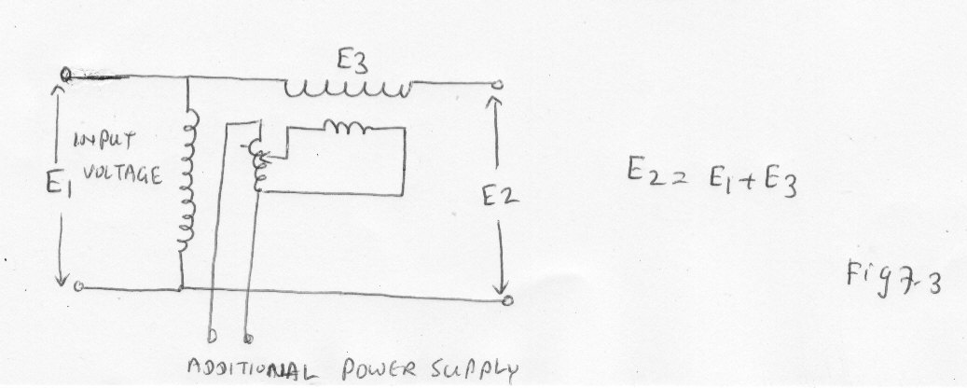

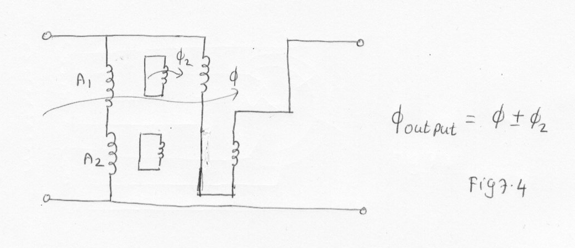
4.2 Describe the reasons effects and limitation of voltage variation

Voltage control
All modern transmission systems with the exception of the constant current system, operate at a constant voltage . It is essential for the satisfactory operation of the consumer’s apparatus that the vltage be kept within narrow limit.

Voltage drop

The conductor must operate so that when the maximum current is being conveyed. The fall in voltage along the line is within certain limit.

SAA Rule

Fall in the potential in the consumer’s mains to any point on the installation does not exceed 5 % of the voltage at the commencement when full current is flowing.

Medium voltage – variation within 6% (Not exceed)
Higher voltage—Variation within 10% (Not exceed)

Power loss

The power loss in the distribution feeders depends on the square of the current and the resistance of the feeder. His loss must be considered in relation to the capital cost involved in the erection of distribution line.

4.3 Recall methods used in controlling voltage level

Fig 7.5
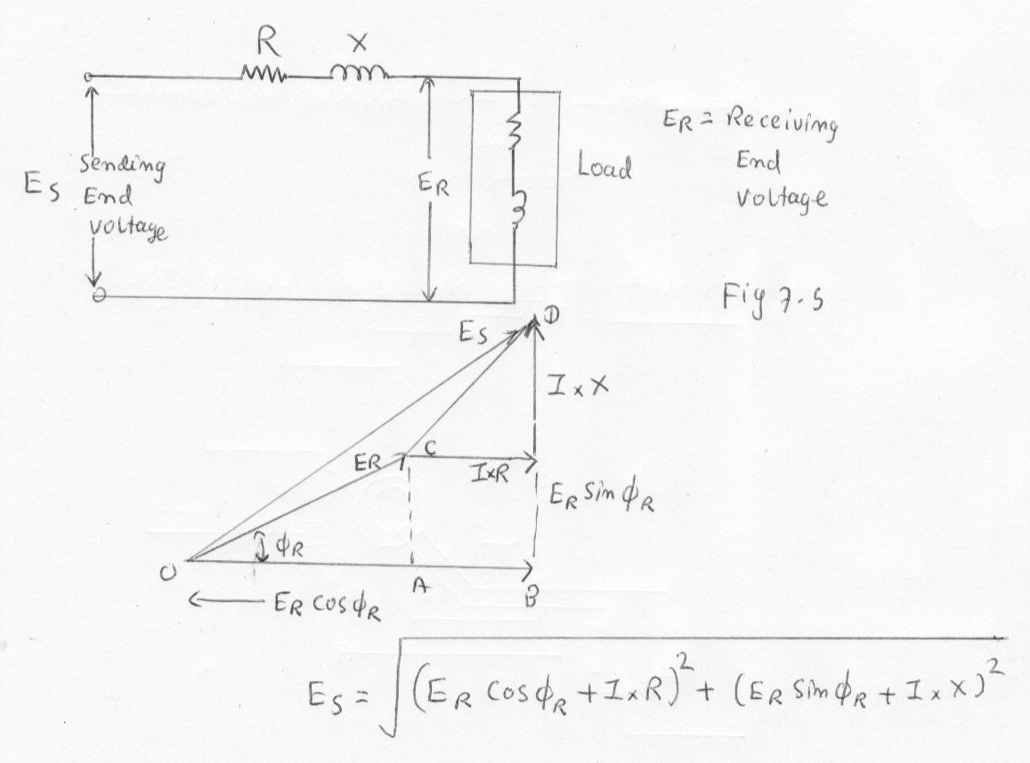

Er= Receiving end voltage

Es = [ ( Er Cosф r + I R )² + ( Er Sin ф r + IX) ² ] ^{½}

Es - Er
Regulation = -------------------------- x 100
Er

IR Cosф r + IX Sin ф r
= ----------------------------- x 100
Er

Methods of voltage control

Three general methods are available for controllling the voltage at the end of a distribution feeder . They are
- By controlling the sending end voltage
- By controlling the receiving end voltage
- By controlling the current in the line that is varying the power factor

Voltage control equipments

- Off load tap changing transformer
- On load tap changing transformer
- Booster transformer
- Moving coil regulator
- Induction regulator

Induction voltage regulator
Fig 7.6
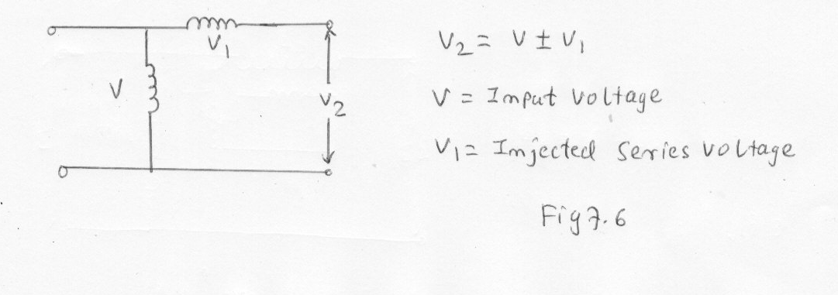

V2 = V +/- V1
V+/ - V1 = V2
V= Input voltage
V1= Injected series voltage

Constant ratio distribution transformer

Light load, zone transformer tap changer is set at 100%.
Heavy load, transformer gives 10% boost

Variable ratio distribution transformer

Zone transformer 10% boost
Variation of far distribution transformer off-load
Tap changer to 2 ½ % boost.

Voltage regulation by control of current

Fig 7.7
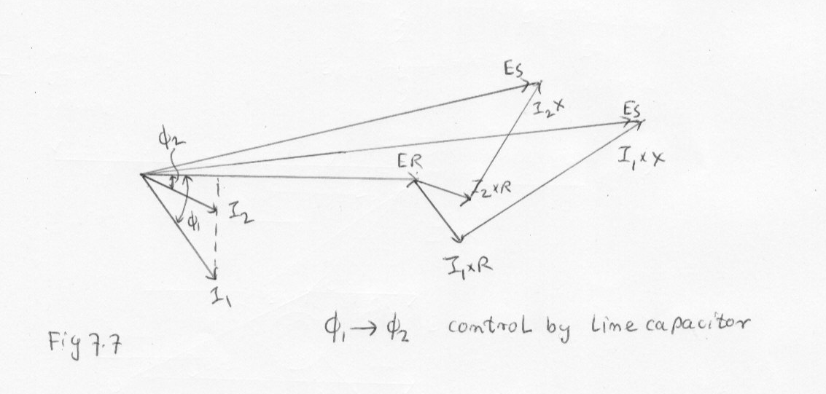
4.4 Draw voltage profile using calculation to determine % voltage drop for components within the distribution feeders.

Voltage profile

Voltage profile charts are useful for studying pattern and to locate causes or reasons for abnormal voltage conditions.

To make such a chart, a common voltage level is selected for the system and the circuit constants such as resistance and reactance are converted to this voltage by means of the formula.

R ₂ = ( E1/E2) ² R ₁

R ₂ = Resistance referred to voltage E2
R ₁ = Resistance referred to voltage E1

E1 and E2 are respective voltage levels.

Fig 7.8
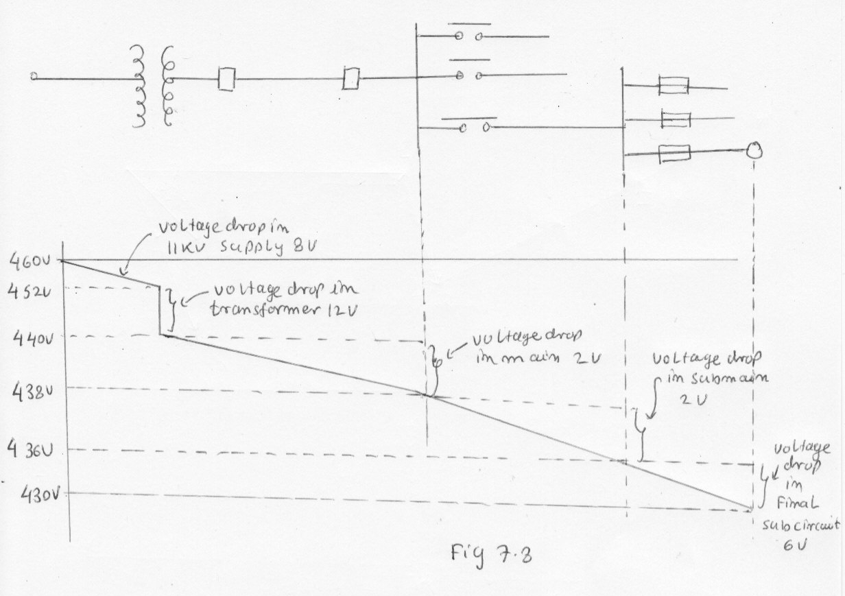

Voltage profile example

The simplified single line diagram of a distribution system is shown in the figure. It is desired to keep the voltage within + 6 % and -4% of the norminal voltage.

Consumers
A, B --- Distribution transformer T1
C, D---- Distribution transformer T2

Fig 7.9
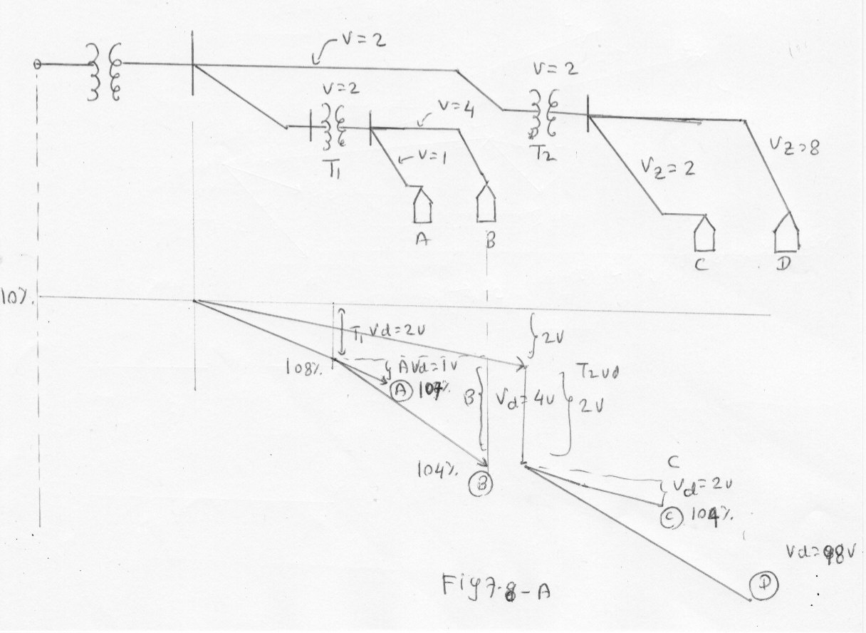

Problem

An industrial consumer takes a load of 100KVA at 0.8 Power factor lagging . Calculate the voltage at the consumer terminal . Given that supply transformer is a half kilometre away and has a sending end voltage of 433 Volts and the conductor has resistance 0.238 Ω/ km and reactance of 0.296 Ω/ km.

100 x 10³
Line current = --------------------- = 133 Amp

  - x 433

V drop = I ( R CosΦ + X Sin Φ)
= 133 ( 0.119 x 0.8 + 0.148 x 0.6)
= 133 (0.0952 + 0.0888)
= 133 x 0.184 = 24.5V

433
Receiving end voltage = --------- - 24.5 = 225.5 V / Ph or 390.5 V /line

3

Problem

From the given graph, determine the minimum voltage rating required for the direct laid single core cable so that a voltage rating of 0.6/ 1 KV can be achieved when
- 2 circuits are in each group with spacing of 0.6 m
- 3 circuits exist in two touching groups.

Fig 7.9

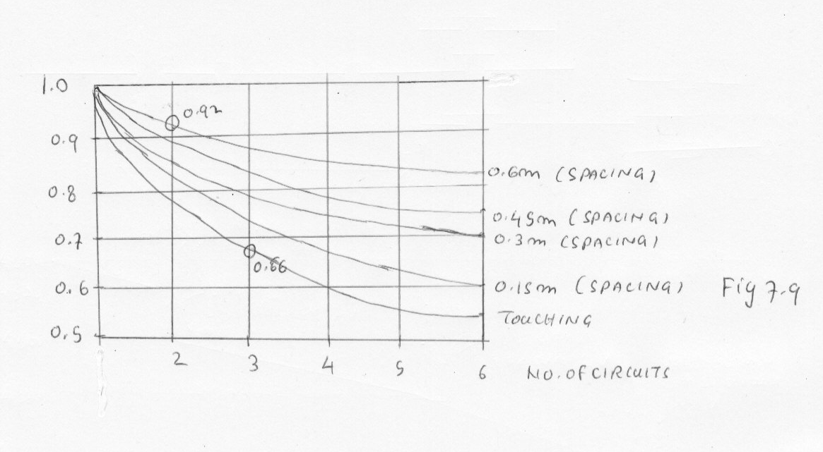

(a)

0.6
Phase to earth voltage = --------- = 0.652 KV
0.92

1
Phase to phase voltage = ---------- = 1.087 KV
0.92

(b)
0.6
Phase to earth voltage = --------- = 0.91 KV
0.66

1
Phase to phase voltage = ---------- = 1.52 KV\
0.66

Problem

For the simplified single line diagram shown, draw the voltage profile for the following full load conditions

- Full load system voltage at point A is 12.19 KV
- Voltage drop in 11 KV supply is 212V
- Voltage drop in 11 KV transformer is 318 V
- Voltage drop in main is 2 V.
- Voltage drop in sub-main is 10 V
- Voltage drop in final sub circuit is 6 V.

Use 415 V as nominal load voltage.

Fig 7.10

Formula

V1 Voltage drop (1)
------- = --------------------------
V2 Voltage drop (2)

Side | Voltage drop | Side | Voltage drop
11 KV line | 12.19 KV | 415 V | 11000 12.19 x 10³  ----------- = ---------------------  - V2  V2 = 459 V
11 KV line drop | 212 V | 415 V | 11000 212  --------- = -----------  - V2  V2 = 8 V
11 KV Transformer drop | 318 V | 415 | 11000 212  --------- = ----------  - V2  V2 = 12 V
 |  | 415 V main | 2 V
 |  | 415 V Sub main | 10 V
 |  | 415 V  Final Sub circuit | 6 V

Real Power = V I Cos Φ (Single phase) , 3 V I Cos Φ (Three phase)

Reactive Power = V I Sin Φ (Single phase)

Apparent Power 3 V I Sin Φ (Three phase)
V I (Single Phase)

3 V I (Three phase)

Φ1 Φ 2

KVAR Improved = KW (tan Φ 1 - tan Φ 2)

Vph ²
KVAR improved = ------------------- x 3
Xc

Problem

A phase load of 200 KVA 50 Hz is to have it’s power factor improved from 0.75 to 0.9. Calculate the size of capacitor bank required if the supply voltage is 415V. Sketch the connection.

Use delta capacitor bank

Φ 1 = Cos ⁻¹0.71 = 41
Φ 2 = Cos ⁻¹0.9 = 26

Kw = 200 x 0.71 = 151 Kvar

Kvar correction = 151 ( tan 41 - tan 26) = 65.2 Kvar

V² 415 ²
Xc= --------- = -------------------
Kvar 65.2 /3 x 1000
1
C = -------------------- = 100 micro farad
2 f Xc

