3.5 Apply cable schedules for underground reticulation scheme

Cable laying

(1) Direct laying (2) Draw in system (3) Solid system

Direct laying

A trench is dug in which the cable is laid, covered with soil. The cable may be protected by planks, bricks, tiles or concrete slabs. Cable should be armour cable. If the ground contains harmful chemicals, the serving must be adequate to protect the cable from corrosion and electrolysis.

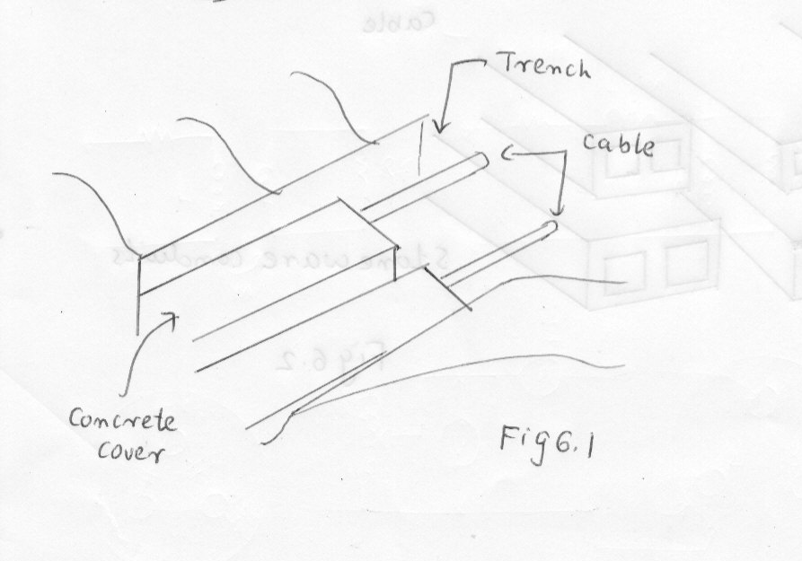

Draw in system

A line of conduits, ducts or tubes is laid in trench. The tubes are of glazed stoneware, cement or concrete. The cables are pulled into the position from manholes or brick pits. It is unnecessary to armour the cable but a serving of heasian type of jute protects the cable when drawing in.

Solid system

The cable is laid in throughing in open trench. The throughing is of stoneware, cast iron, asphalt or treated wood. After the cable is placed in position, the throughing is filled with a bituminous or asphaltic compound and covered over. Cable can be laid with a bare sheath and is immune from electrolysis as the sheath is electrically insulated from earth.

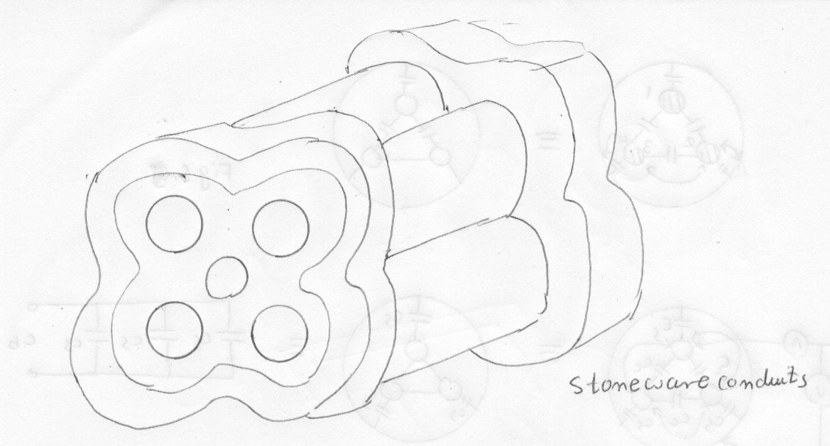

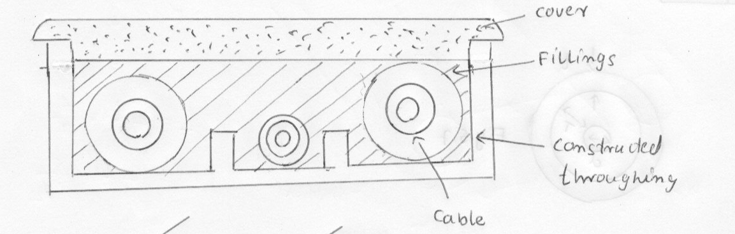

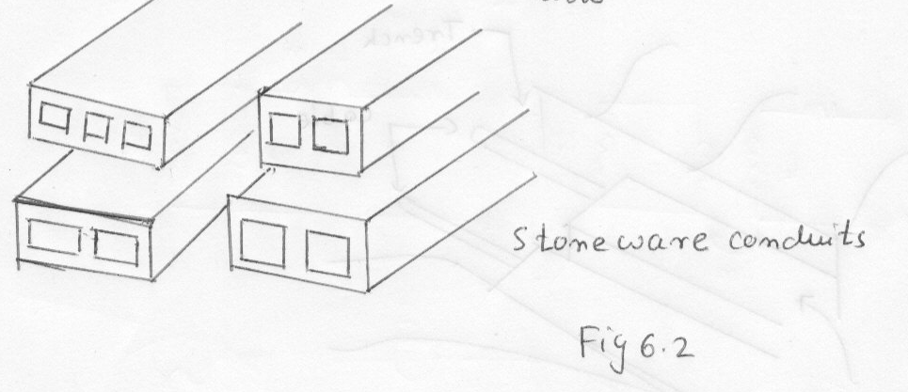

3.5 Apply cable schedules for underground cable installation

Joining

The most common way of joining the conductors is to insert the ends into a ferrule which is a slotted metal tube, and solder the whole solid.

With oval cables, the ferrule is made in two halves which can be turned with respect to one another in order that the cables need not be twisted to make their axes parallel. Packing adaptors are being used.
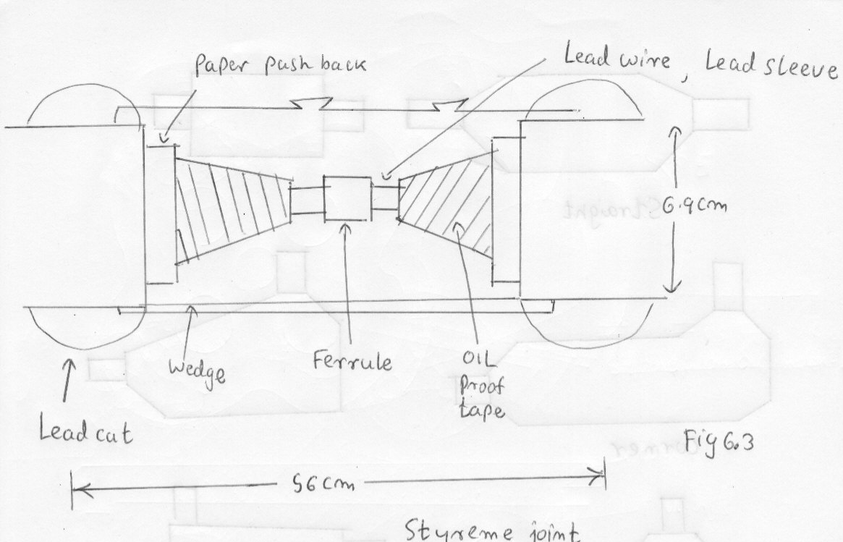

Method

- Lead sheath is cut back 60 cm, the paper in 7 cm.
- Load sleeve, lead flame, paper tube are passed back along the conductor.
- The ferrule is put on and the parts are soldered together.
- The paper is pencilled back 3.2 cm and metallised paper is cut back to within 3.8 cm of lead.
- The paper tube is slipped into position and fixed by 4 narrow wedges
- Which are jammed by layers of oiled silk tape
- Joint is filled with compound. No air will be on trapped
- Oil proof tape is wrapped over the end of lead sheath to prevent oil from flowing from the joint into cable
- Lead flame is placed in position and lead wire is wrapped on
- Lead sleeve is put in position and plunked at the ends and middle
- Bending strands are fixed
- Joints is filled with oil

ρ D
Insulation resistance of cable = ------------ Ln ----------
2 L 2r

Conductor radius = r Internal sheath radius = 1/ 2 D

Problem

Find the insulation resistance per Km of cable of conductor diameter. 1.6 cm and internal sheath diameter is 5.08 cm. ρ = 6 x 10 ¹⁴ Ω-cm

ρ D
Insulation resistance of cable = ------------ Ln ----------
2 L 2r

6 x 10 ¹⁴ 5.08
Insulation resistance of cable = ----------------------------- Ln ----------
2 x 3.14x 10 ³ x 10² 1.6

= 0.955 x 10 ⁹ x Ln 3.175

= 0.955 x 10 ⁹ x 1.155
= 1.103 x 10³ MΩ
= 1103 MΩ

Problem

In above problem, if the cable is subject to 66KV 3 phase line, find dielectric loss.

E line = 66 KV

66 x 10 ³
E ph = ----------------- = 38104 V

3

Eph ²
Therefore dielectric loss = -----------------------
R insulation

38104 ²
Therefore dielectric loss = -----------------------
1103 x 10 ⁶
Therefore dielectric loss = 1.316 watts

Underground cables

Low tension cable -- Below 1000V

Insulation material may be impregnated paper, varnished cambric, vulcanised rubber or vulcanised bitumen

Insulation

Thickness of dielectric at 660 V between 0.2 cm and 0.28 cm
Varnished cambric is coated with petroleum jelly to provide lubrication between layers so that bending of cable is possible without damage

Vulcanised bitumen - Refined bitumen is melted and sulphur and vegetable oil are added.

Sheath

Lead sheath - Vat field of use

3.6 Describe techniques used to install cable and associate equipments

Ducts

To expand future installation

Iron / reinforced concrete/ steel pipe/ wood / fibre/ plastic

Fig 6.4

Duct type | Cost of construction | Ability to radiate heat | Cost of support
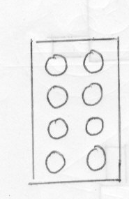 | Expensive | Best | Best
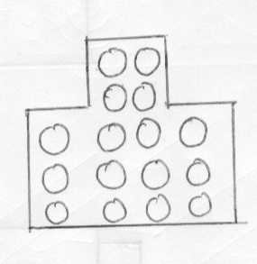 | Moderate | Very good | Very good
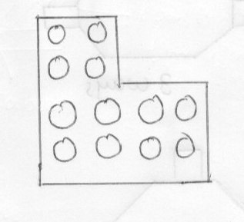 | Moderate | Very good | Good
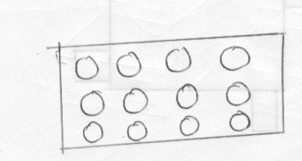 | Cheapest | Very poor | Very poor

Service boxes

Secondary mains are installed in ducts buried at shallower depths than those carrying primary conductor. Precast reinforce concrete is used.

Cable manhole

- Rectangular for straight line conduit construction.
- Square for accommodating from 4 directions.

Fig 6.5

Transformer Manholes

Transformer manholes are designed to contain transformers and other equipments for radial or network system.

Fig 6.6
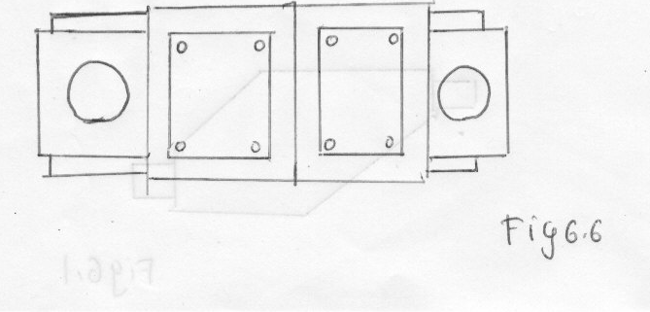

Design loading on manhole

Wheel load ( 1 + % Impact / 100)
Concentrated load = ----------------------------------------------------------------
Wheel Area

Problem

Wheel load 9576 Kg , imposed 50% for heavily travelled street under which truck traffic may be concrete. Wheel area is 15.5 cm x 30.5 cm

Calculate concentrate load on manhole cover.

Wheel load ( 1 + % Impact / 100)
Concentrated load = ----------------------------------------------------------------
Wheel Area

9576 ( 1 + 50 / 100)
Concentrated load = ----------------------------------------------------------------
15.5 x 30.5 x 10⁻⁴

14364 x 10 ⁴
= ----------------------------------------------------------------
472.75

= 303839 Kg / m²

Roofs

Manhole roofs are designed as a series of structural steel beams or rail or reinforced concrete with extra reinforcement or structural steel to support manhole frames

Wall

Manhole wall designs are based on the horizontal component of the effect of both line and dead loads acting on the walls.

Floors

In the design of manhole, floors , the load bearing power of the soil and the height of the water tube play an important part. The soil most support the weight of the manhole structure its contents and any imposed surface level loads.

Frame / covers

- Made of cast iron/ malleable iron/ steel
- Are designed to withstand the loadings of traffic
- May be made of reinforce concrete

Ventilation

- Principal heat source is power loss in windings
- Tube ventilation is natural ventilation
- Large conductors are put in separate ducts
- XLPLE/ Lead/ Plastic insulation are used.

Fig 6.7 Cross section of joint

Underground Equipments

transformers, oil filled cutouts and oil switches for use underground are hermetically sealed so as to be water proofed

Such submersible equipment is usually of welded construction. Wiping sleeves are welded or brazed directly to the tank or terminal chamber to which cable sheaths are attached.

Barriers in the conductors prevent the equipment oil from being siphoned into the cables.

