3.1 Determine the construction features and insulation abbreviations of underground power cables

Fig 5.1
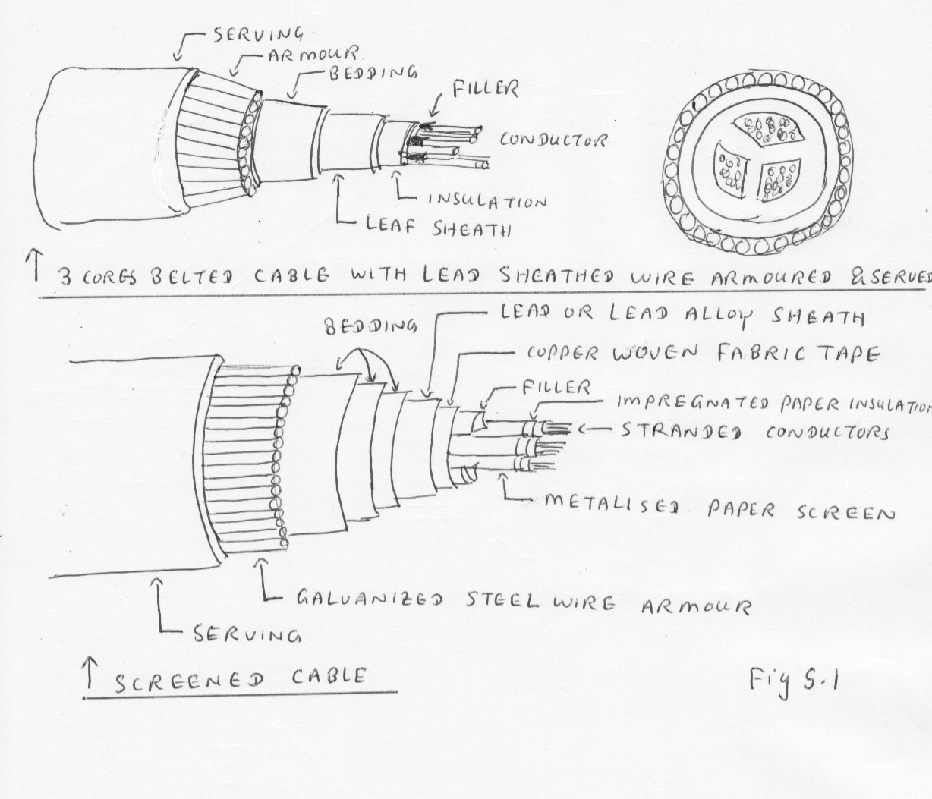
Cable

The majority of cables used for distribution works are impregnated paper insulated cables with a lead or lead alloy sheath.

AS 1026 standard is applied.

Properties | Unit | Annealed copper | 99.5 % Purity Aluminium ¾ H | 99.5 % Purity Aluminium as extruded
Density | g/ cm ³ | 8.89 | 2.703 | 2.700
Resistivity | Ohm at 20 ˚ C | 1.7241 x 10⁻⁸ | 2.8264 x 10⁻⁸ | 2.803 x 10⁻⁸
Temperature coefficient of resistance | Per ˚ C | 0.00393 | 0.00403 | 0.00403
Melting point | ˚ C | 1083 | 658 | 658
Coefficient of elongation | Per ˚ C x 10⁻⁶ | 17 | 23.8 | 23.8
Ultimate tensile strength | K Pa | 241 | 124 | 83

¾ H -- ¾ Hard

Types of cables

- Single core cable
- Belted cable
- Screened cables
- Multicore SL Cables
- Multicore HBL Cables
- Oil filled cables
- Gas filled cables
- Plastic insulated cables

Rating factor

Tables of current ratings for cables always specify some ambient temperature and the number of cables which are in close proximity.

In practice , the ambient temperature may be higher than that used for design conditions and so reduced current rating must be used.

Maximum conductor temperature  ˚ C | Rating factor
 | Ground temperature for cables laid direct or in ducts | Air temperature for cables laid in air

 | 15˚ C | 20˚ C | 25˚ C | 30˚ C | 25˚ C | 30˚ C | 35˚ C | 40˚ C | 45˚ C
60  65  70  80 | 1.14  1.12  1.11  1.09 | 1.07  1.06  1.05  1.04 | 1.0  1.0  1.0  1.0 | 0.92  0.96  0.94  0.95 | -  1.26  1.22  1.16 | -  1.18  1.15  1.12 | -  1.10  1.08  1.06 | -  1.0  1.0  1.0 | -  0.89  0.91  0.93

Current rating of cables

The current rating of cables is determined by
- The thermal capacity of the cable
- The voltage drop
- Short circuit capacity

Sheath current

Sheath currents may be divided into two kinds, namely

- Currents whose outward and return paths lie entirely in the sheath of one cable - sheath eddies
- Currents whose outward and return paths are formed by the sheath of separate cables- sheath circuit eddies

Conditions

- Where cables are fixed to a vertical surface or wall the distance between the wall and the surface of the cable should not be less than 20 mm
- Cables of which the cross sectional area does not exceed 185 sq mm should be installed at a distance between centres of not less than twice the overall diameter of cable
- Cables of which the cross sectional area does not exceed 185 sq mm should be installed at a distance between centres.
- Cables should be removed from iron and steel other than cable supports

Conductor temperatures

Maximum permissible continuous conductor temperature for paper insulated cable.

Voltage rating of cable (KV) | Type of cable | Maximum permissible temperature ˚C
0.6 / 1  1.9 / 3.3  3.8 / 6.6  6.35 / 11  12.7 / 22  19 / 33 | All types  Single core  3 cores-Belted  3 cores-screened  All types | 80 ˚C  70 ˚C  65 ˚C  70 ˚C  65 ˚C  65 ˚C

3.2 Calculate cable voltage drop in relation to length of cable run

The actual voltage drop (Vd) for a particular cable in given circuit is calculated using the equation.

Vc x L x I
Vd = ------------------
1000

Where

Vd = Actual voltage drop in volts
Vc = Unit voltage drop in millivolts per ampere metre (mv / A-m)
L = Route length of circuit
I = Current to be carried by the circuit (Usually maximum demand)

1000 x Vd
Vc = ----------------------
L x I

Single and three phase voltage drop

Conversion of the unit voltage drop Vc ( mv / A-m)

3 Phase Vc = Single Vc x 0.866
Single phase Vc= 3 Phase Vc / 0.866

Conversion of the actual voltage drop Vd (Volts)

3 Phase Vd = Single phase Vd x 3

3 Phase Vd
Single Phase Vd = ------------------------

3

Cable selection based on voltage drop

Load
Consumer
MSB
terminals

Cable selection based on voltage drop Cable selected on current carrying capacity sizes and
voltage drop are known

Problem (1)

Calculate the voltage drop in each segment of a 3 phase 400 volt non-domestic installation consisting of the followings.

Consumer main

Phase = 3 Maximum demand 45 Amp Route length = 25 m

Cable size 16 mm ²
Cable configuration V90 Single core thermo plastic and sheathed copper conductor

Cable installation
The circuit is enclosed in heavy duty rigid thermoplastic conduit with no other circuits. Conduit is buried in the ground having an ambient soil temperature of 25 ˚C and has a top cover of 0.65 m.

Sub main

Phase = 3 Maximum demand = 35 A, Route length = 35 m
Cable size = 10 mm²

Cable configuration
V90 Single core thermoplastic and sheathed copper conductors structure in trefoil formation and installed in single circuit configuration unenclosed in air

Final sub circuit

Phase = 1 Maximum demand = 20 Amp Route length = 35 m
Cable size = 4 mm ²

Cable configuration - V90 two cores and earthed thermoplastic and sheathed copper conductors
Cable installation - The cables are clipped to the building structure and installed in single circuit configuration , unenclosed in air.

Does this portion of the installation comply with the voltage drop requirement of AS/NZS 3000 ?

Consumer main

V90 single core / enclosed in conduit-- Select Table 41 (Page 81 of AS/NZS 3008 1.1 1998)

1000 x Vd
L = -------------------------------
I x Vc

1000 x Vd 25 x 45 x 2.55
25 = ------------------------------ Thus Vd = ----------------------------- = 2.868 (3 phase voltage drop)
45 x 2.55 1000

2.868
For single phase voltage drop = -------------------- = 1.655V

3

Sub main

V90 cables are clipped to building structure in trefoil formation.

Select Table 40 (Page 80 of AS/NZS 3008 1.1 1998)

1000 x Vd
L = -------------------------------
I x Vc

L x I x Vc 35 x 35 x 4.05
Vd = ------------------------------ = ------------------------------ = 4.96V (3 phase voltage drop)
- 1000

4.96
For single phase voltage drop = ---------------------- = 2.86 V

3

Final sub circuit

V90 two cores
The cables are clipped to the building structure and installed in single circuit configuration unenclosed in air.

Table 42 Page 82
3 phase Vc 10.2
Single phase Vc = -------------------------------------- = ------------------------- = 11.77
0.866 0.866
1000 x Vd
L = -------------------------------
I x Vc

L x I x Vc 35 x 20 x 11.77
Vd = ------------------------------- = ---------------------------- = 8.23 V
- 1000
Total single phase voltage drop = 1.655 + 2.86 + 8.23 = 12.7 V

5 x 240
5% of 240 V = ----------------- = 12.V
100

The actual voltage drop 12.7 V is higher than limitation 12 V .

It does not comply with AS/ NZS 3000:2000.

3.3 Recall techniques to reduce electrical stresses on cables

To reduce the stress

- Stand properly
- Careful in bending / cutting/ removing insulation
- Follow the proper procedure in connection
- Take account on external conditions
- Take account on temperature
- Take account on installation conditions
- Set appropriate tension of conductors
- Select appropriate materials to enclose cable. Select appropriate cable materials for relevant condition.

Implication and type of duty

Current condition, voltage drop consideration, operating voltage

Bending of cable

Excessive bending of cables during their installation will reduce their working life.

Temperature rating

V75 -- Working temperature 75 ˚C
V105 -- Working temperature 105 ˚C

Polytetrafluorethylene (PTFE) -- Working temperature 200 ˚C

Enclosure of cables

- Determine overall cross sectional area of each cable to be installed in conduit/ trench / cable way
- Calculate total overall cross sectional area of all cables to be installed in conduit / trench / cable way trunk.
- Determine required conduit / trench / trunk size
- Check the proposed conduit enclosure will conform to the requirement of regulations.

Type of conductors

Copper

- High conductivity per unit area
- Easily mechanically joined (or) soldered \
- Expensive
- Resistant to corrosion
- Stronger than aluminium

Aluminium

- High conductivity per weight
- Must be joined with a joining paste since aluminium oxide , an insulator forms almost immediately after cleaning.
- Cheaper than copper but it’s coefficient of expansion must be taken in to account when joining.
- It is not as resistant to corrosion
- Weaker than copper
- When used in installation such as aerials, aluminium cable is usually steel cored to add strength

Performance of cable insulation material will be drastically affected if the cable is exposed to weather, oil, abrasion and chemicals

  - Recall cable rating factors, method of cable joining

Stripping cable

Use knife / plier / stripper

Termination- Solder / crimp ----Adjustable crimper 10 to 120 mm ² cable
For large cables-- hydraulic crimpers are used.

3.7 Recall cable testing techniques and methods to locate the fault

Stress in 3 cores cable

Even when the dielectric is homogeneous , the problem can not be solved with accuracy, and as the dielectric is never homogeneous because of the fillers, there is no point in quoting or working from formulae. There is a rotating electric field in the 3 core cable and the maximum stress occurs at the point nearest to the centre on the conductor at maximum voltage.

It is however almost certain that this stress is not the determining factor in the life of the cable. It is normal for the paper and is more easily borne than the lower stresses which occur in and near the fillers and are tangential to the papers. It was found in the 3 core 33KV cables that deterioration began in the fillers and warming and not at the point of maximum stress on the conductor

Fig 5.2

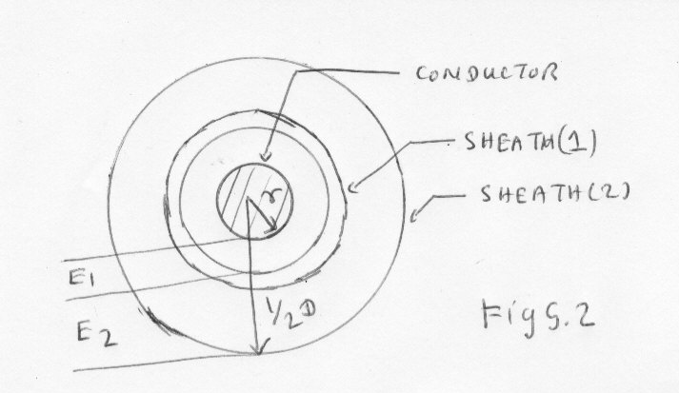

E
Stress without sheath = S max without sheath = ------------------------------- Volt / mm

½ d Ln D/d

2 E rms
E = Peak voltage per phase = ---------------------------------

3

S max without sheath
Stress maximum with sheath = --------------------------------------------------------

3 ( 1 + α + α ² )

For double sheath

E
E ₂ = ----------------------------------------------------------------
1 1
1 + ------------------ + -------------------
α α ²

1
E ₁ = E ₂ ( 1 + ------------------- )
α

Problem

A single core 66KV cable has a conductor diameter of 2 cm and a sheath of inside diameter 5.3 cm . Find the maximum stress. If two inter-sheaths are used, find the best positions, the maximum stresses and the voltage on inter-sheaths.

D = 5.3 cm d = 2 cm Thus D / d = 5.3 / 2 = 2.65

D / d = α ³ Thus α = 3 2.65 = 1.384

66 x 2
Peak voltage on conductor = ------------------------- = 53.8 KV

3

E
E ₂ = ----------------------------------------------------------------
1 1
1 + ------------------ + -------------------
α α ²

53.8
= ----------------------------------------------------------------
1 1
1 + ------------------ + -------------------
1.384 1.384 ²

53.8
= --------------------------------------------------------------------
1 1
1 + ------------------ + -------------------
1.384 1.91

= 23.9 KV

1
E ₁ = E ₂ ( 1 + ------------------- )
α
1
= 23.9 ( 1 + ------------------- ) = 41.1 KV
1.384

Peak voltage
Maximum stress without inter-sheaths = ---------------------------

½ d Ln D / d

53.8
= --------------------------------
½ x 2 x Ln 5.3 / 2

53.8
= --------------------------------
Ln 2.65

= 55.3 KV/ cm

S max without sheath
Stress maximum with sheath = --------------------------------------------------------

3 ( 1 + α + α ² )

55.3
Stress maximum with sheath = --------------------------------------------------------

3 ( 1 + 1.384 + 1.384 ² )

55.3
Stress maximum with sheath = --------------------------------------------------------

3 ( 1 + 1.384 + 1.91 )

= 38.7 KV / cm

Sheath effect

The currents induced in the sheaths are of two kinds.

Sheath eddies - Whose paths lie in the sheath of a single cable and which flow even when the sheaths are isolated from each other.

Sheath current eddies – Whose paths lie in the sheaths of separate cables and flow only when the sheaths are bonded.

Sheath eddy paths

Fig 5.3

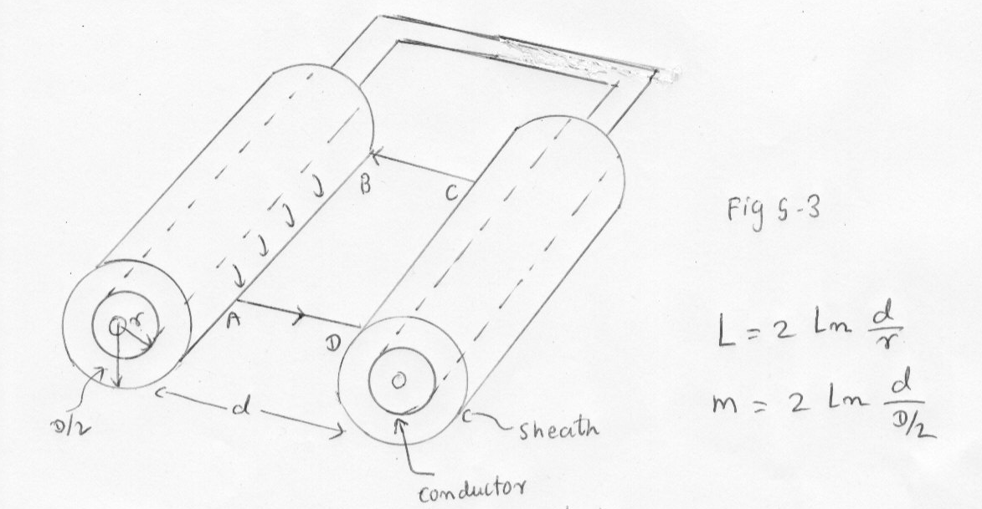

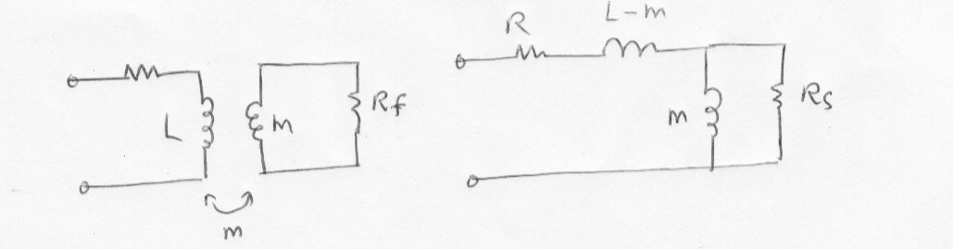
L = 2 ln d / r

d
M = 2 Ln -------
D / 2

d
Flux =0.4 Ln -------
D / 2
d
Induced voltage = 4 w I Ln ------------- x 10 ^{–9} Volt / cm length
D / 2

Capacitance in 3 core belt type cable

Fig 5.4
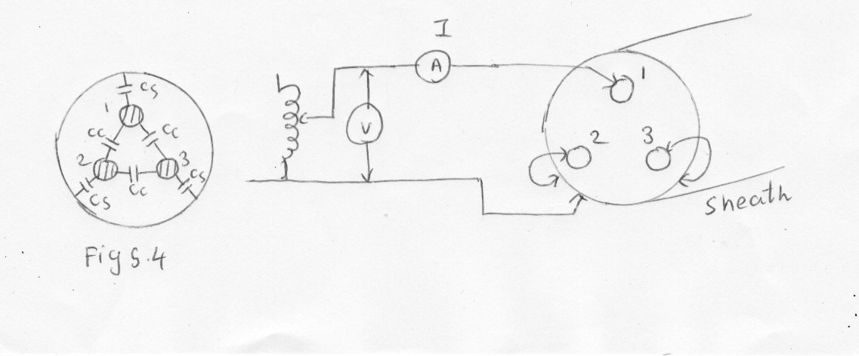

Conductor 2 and 3 are connected to sheath and measure the capacitance between conductor 1 and the rest.

V
Xc = -----------
I

1 V
------------------ = -----------
2 f c I

I
C = -------------------------
V x 2 x x f

Fig 5.5
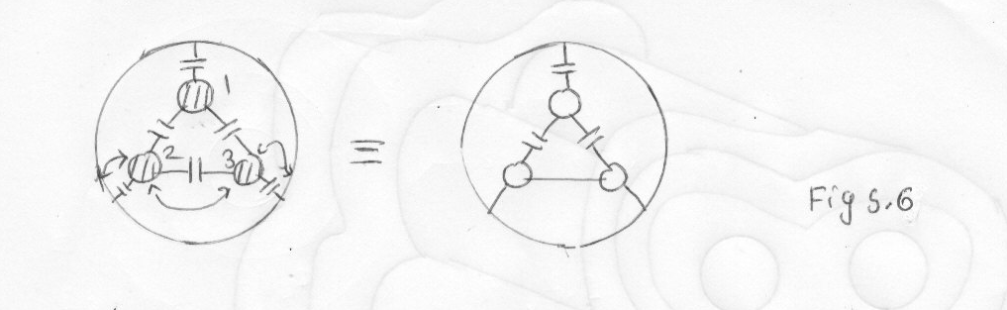
Total capacitance = Cs + 2 cc

Thus Ca = Cs + 2 Cc------- Eq 1

Allconductors are connected and the capacitance be measured between conductor 1 and the rest.

Fig 5.6

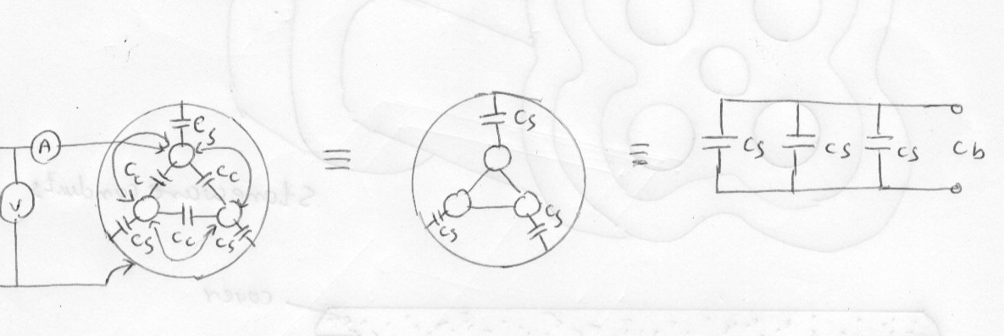

Cb = 3 Cs -------------- Eq 2

1
Thus Cs = ---------- Cb
3

By this way the capacitance to sheath is measured.

Then the capacitance between conductor is clculated

Ca = Cs + 2Cc

1
Ca = ----- Cb + 2 Cc
3
1
Cc = ½ ( Ca - -------- Cb )
3
Ca Cb
Cc = --------- - --------------
- 6

By this way the capacitance between conductor is measured.

Problem

Conductor 2 and 3 are connected , measured capacitance between conductor 1 and the skin in 6 micro farad.

All conductors are connected, measure the conductor and the skin is 4 micro farad.

Calculate Cs and Cc.

When all conductors are connected

1
Cs = ------- Cb
3

1
Cs = --------- x 4 = 1.333 micro farad
3

When conductor 2 and 3 are connected.

Ca = Cs + 2 Cc

6 = Cs + 2 Cc

Cs + 2 Cc = 6

1.33 + 2 Cc = 6

6 – 1.33
Thus Cc = ------------- = 2.335 micro farad
2

Capacitance to neutral Co

0.048 έ 1
Co = --------------------------------------------------------------------------------------- x ----------- micro farad / Km
T + t t t ² 1.609
Log [ 1 + -------------- { 3.84 - 1.7 ---------- + 0.53 ----------- } ]
d T T ²

Fig 5.7
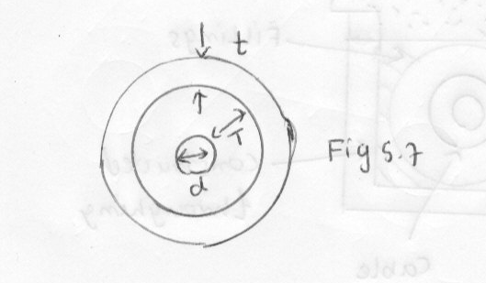

d = Conductor diameter
T = Thickness of conductor insulation
t = Thickness of belt insulation
έ = Dielectric constant

Problem

Diameter of conductor = 1.65 cm Dielectric constant = 3.6
Conductor insulation = 0.508 cm Thickness of belt = 0.43 cm
Calculate Co .

0.048 x 3.6 1
Co = --------------------------------------------------------------------------------------------------- x -----------------
0.508 +0.43 0.43 0.43 ² 1.609
Log [ 1 + ------------------ { 3.84 - 1.7 ------------- + 0.53 ----------------- } ]
1.65 0.508 0.508 ²
0.48 x 3.6 1
= ------------------- x ---------- = 0.26 micro farad / Km
Log 2.57 1.609

Cable testing technique and methods to find the location of cable fault

Fault finding methods

- Sectionalizing --- Divide the line route in to smaller sections. Test each section

(2) Thumping—Supply high voltage in to faulted cable resulting high current arc makes a noise loud
enough to hear it by tester above the ground. Applied voltage is 25 KV.

Disadvantage --- It can degrade the insulation

- Time Domain Reflectory (TDR)

Send a low energy through the cable causing no insulation degradation . Perfect cable returns the signal in a known time and known profile.

Impedance variation in cable alter both time and profile which TDR screen or print

Weak point - It does not pin point the fault.

- High voltage radar method

  - Arc reflection
  - Surge pulse reflection
  - Voltage pulse reflection

Arc reflection -------Use TDR and Thumper ----- It provides appropriate distance to fault

Surge reflection ----Use current coupler and storage oscilloscope - It can find the difficult faults

Disadvantage -- High out put surge can damage the cable and it needs skill to interpret.

- Voltage pulse reflection

Voltage pulse reflection uses a voltage coupler and analyzer with a dielectric test set of proof tester.

This method provides a way to find faults that occur at voltage above the maximum thumper voltage of 25 KV.

Open neutral

Open neutral and bare neutral can be corroded quickly in contaminated soil that holds corrosive chemicals or excessive moisture

Open neutral often thwart the effectiveness of high voltage radar.

Test to detect open neutral

Shorting a known good conductor to suspect neutral.
Measure the resistance with ohm meter
Reading 10 ohm or higher, it can be suspected that there is an open neutral.

Use of TDR method

When the neutral is open, there will be no reflected pulse. If TDR displays the open neutral, AC voltage gradient test set can locate the break in a direct buried unjacketed cable.
Test set transmitter forces AC current to flow through neutral. , then detect the resulting voltage gradient in soil.

Equipments applied for cable fault location

TX 2001 TDR cable fault locator
Megger cable fault locator
Computerware TX 2002 / 2003

