2.5 State pole and line installation technique

- All poles framing materials must be delivered in the worksite to exact designated positions.
- All structures must be assembled or framed and placed so as to be set without moving equipments
- All holes are dug.
- The setting rig must come by , set the pole and hold it until tamping or backfill crew can screw it.

Construction foundation

- Prepare foundation (Types of foundation and methods will follow)
- Deliver materials to site
- Assemble
- Erect

Maximum conductor tensions are specified.

Tension (N/m) Heavy Medium Light
4.4 2.9 0.73

Line planning

Line profile drawing

Plan profile drawings are the drawings that show a topographical contour map of the terrain along and near the worksite and a side view profile of the line showing elevation and towers.

The transmission line plan profile drawings serve as a worksheet and eventually shows what is to be done and the problems involved. Initially the drawings are prepared based on a route survey showing land ownership. The locations and elevations of all natural and man made features are to be crossed if they are adjacent to the proposed line. The drawings are then utilized to complete the line design work such as structure spotting. During material procurement and construction, the drawings are used to control the purchase of materials and to prepare the construction specific drawings.

After the construction, the final plan profile drawings become the permanent records of property and data which is useful in line operation, maintenance and in planning future modifications.

Line Drawing Sheet

Important aspect of line drawing.

- Accuracy
- Clarity
- Completeness
- To ensure economical design and construction

Provisions are to be noted with brief description of the revision. Errors in plan profile drawing can cause the construction error. Final field check of the structure site should reveal any error.

Scale

2.5 m to 1 mm for horizontal scale
25 cm to 1 mm for vertical scale

The plan profile should accommodate 1 Km of line.

The scope format for a plan profile drawing is shown in Fig 4.1. Increase in stations and structure numbering usually proceeds from left to right with the profile and corresponding plan view on the same sheet.

Existing features are to be crossed by transmission line including the height and positions of power and communication lines should be shown and noted by station and description in both the plan and profile views. The magnitude and directions of all direction angles in the line should be given and referred in plan and elevation.

Fig 4.1
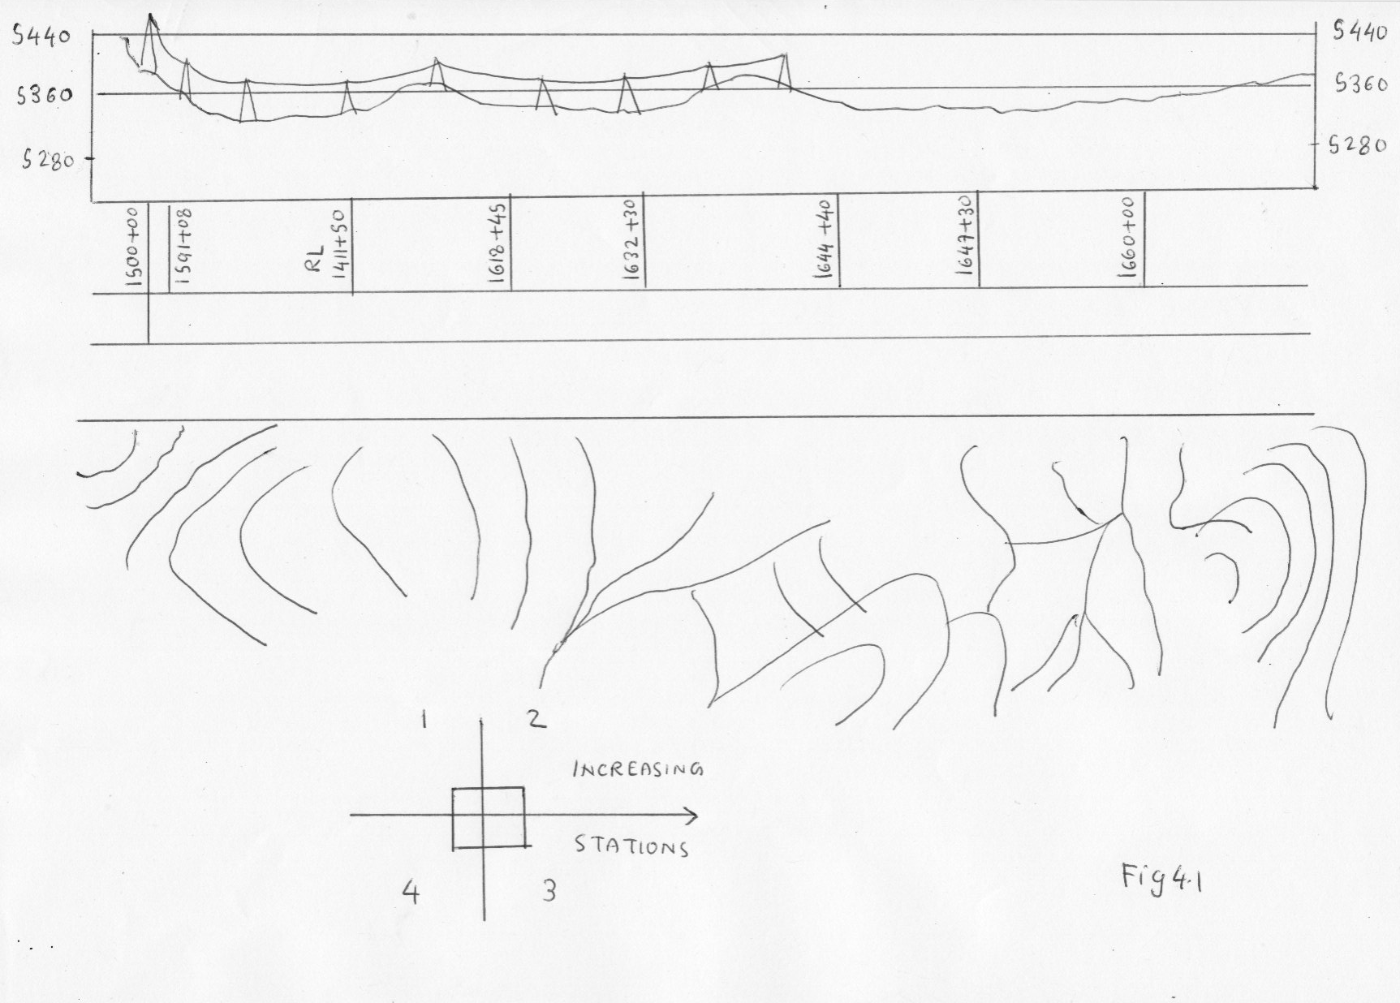

Final drawing

The conductor and ground wire sizes, design tensions, ruling span and the design loading conditions should be shown on the first sheet of the plan-profile drawings. A copy of the sag template should be shown. The actual ruling span between dead-ends should be calculated and noted on the sheets.

As conductor sags and structures are spotted on each profile sheet, the structure locations are marked on the plan view and examined. Beginning with initial preparation, accuracy, clarity and completeness of the drawings should be maintained to ensure economical designed and construction. All revisions made subsequent to initial preparation and transmittal of the drawings should be noted in the revision blocked by date and with brief description of the revision.

Drawing preparation begins with an aerial survey followed by a ground check. The proper translation of these data to the plan-profile drawings is critical. Errors that occur during this initial stage affect line design because graphical method is used to locate the structure and conductor. The final field check of the structure site should reveal any error. Normally plan-profile ensure that the locations are satisfactory and do not conflict with existing features or obstructions. To facilitate preparation of a structure list and the tabulation of the number of construction units, the following items , where required should be indicated at each structure station in the profile view.

- Structure type designation
- Pole height and cross height of tower
- Pole top, cross arm or brace assemblies.

Fig 4.2, 4.3, 4.4, 4.5
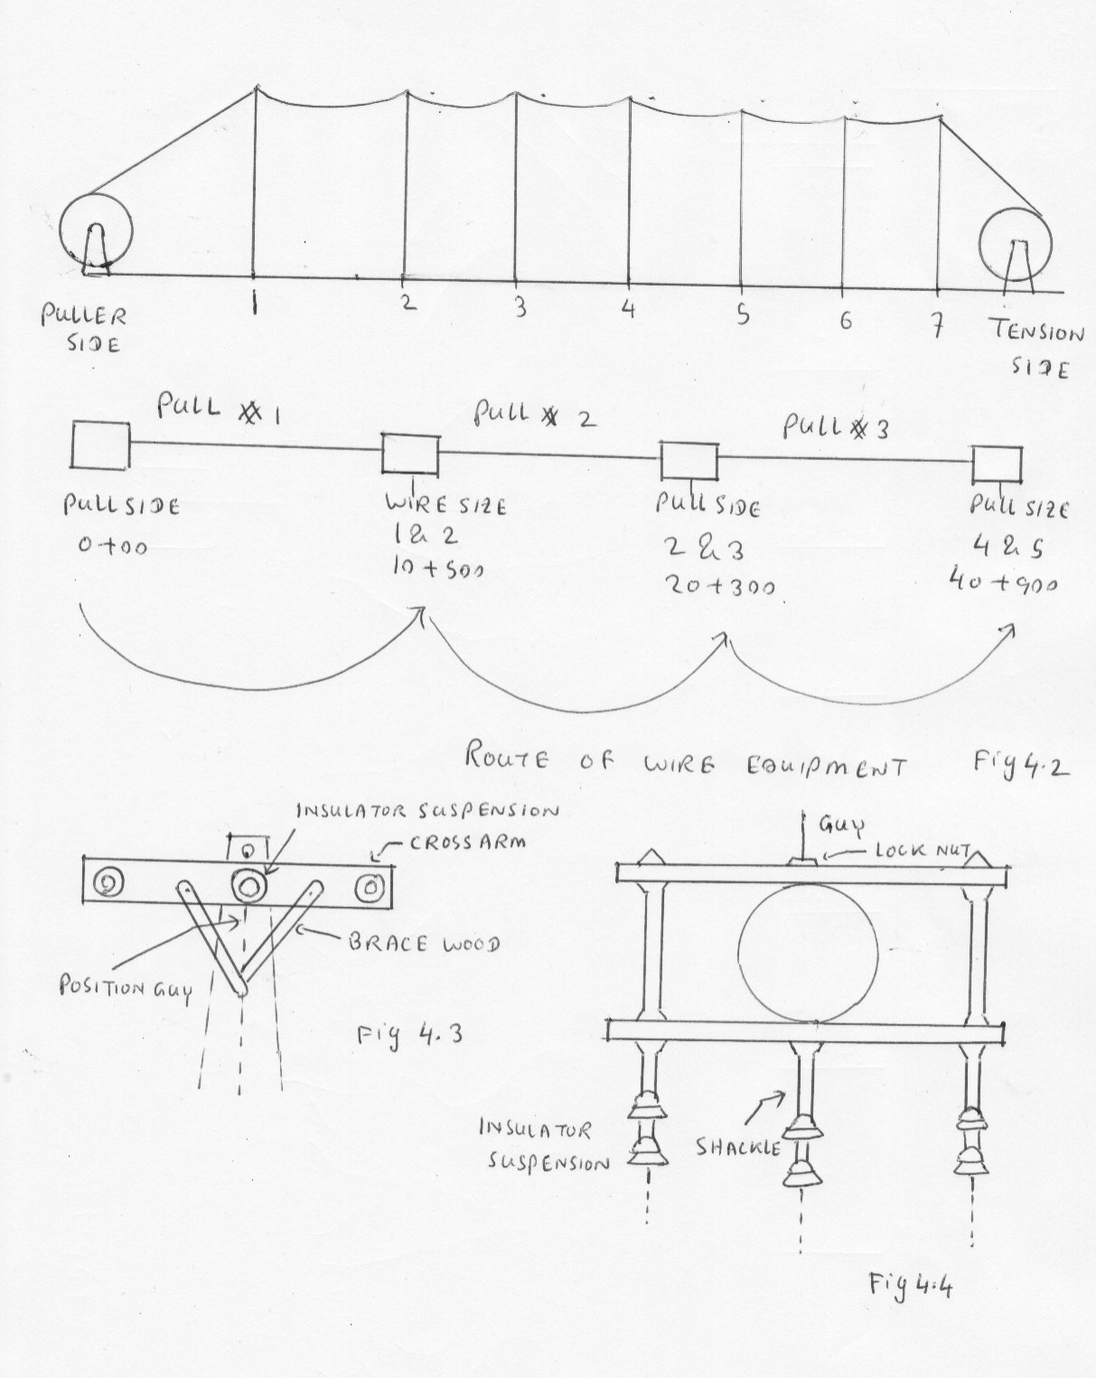

2.6 Recall regulations pertaining to overhead lines

Wind loading α/ 2

Line tension Resultant force on insulator due to change of direction
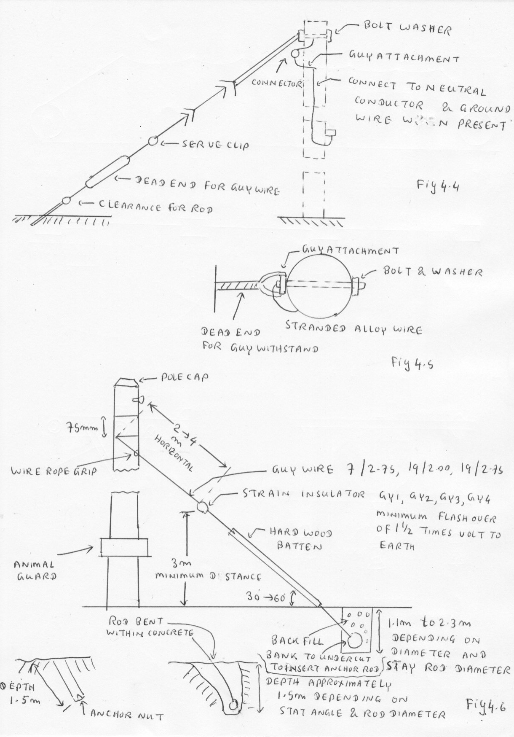

Regulation 12- Protection against corrosion

All iron and steel fittings must be protected by galvanizing or other suitable means. It is necessary to have a minimum deposit of 160 grams of zinc / square meter and hot dip galvanizing should be called for any specification for line fittings.

Regulation 13- Insulation

There must be of adequate strength pin insulators must not be used for strain or termination construction .Where the direction of an over head conductor is changed , there is a resultant load acting on the insulator in addition to the possible wind loading

Permissible line deviation

Resultant force on pin = 2 T Sin α / 2 + W_{l} l Cos α / 2

For small angle, Cos α / 2 = 1

Thus Resultant force on pin = 2 T Sin α / 2 + W_{l} l

Where

W_{l} = Wind load on conductor N/m = Wind pressure x Diameter of conductor x 1 m length

l = Span length in metre

T = Maximum tension in conductor (N)

α = Angle of line deviation

Problem

Determine the maximum deviation allowed on 11 KN pin insulator for a 7/ 3.50 hard drawn copper conductor with a span of 150 m. The ultimate strength of the conductor is 26600N. The wind load is to be taken as 500 Pa and the diameter of the conductor is 10.5 mm. Tension in conductor must not be more than 50% of ultimate strength. Transverse loading on pin insulator is not to exceed 40% of ultimate strength.

W_{l} = Wind load on conductor = 500 x 10.5 x 10 ⁻³ = 5.25 N/m l = 150m

Pin load = 2 T Sin α / 2 + W_{l} l

40 x 11000 2 x 26600 Sin α / 2 + 5.25 x 150
---------------- = -------------------
100 2

3612.5
Sin α / 2 = --------------
26600

α / 2 = 7.8 ˚

α = 15.6 ˚ Angle of deviation

Regulation 14 Loading condition

Wind load = 500 Pascal
Regulation 15 Aerial conductor

All conductors must be stranded and all normally available materials are allowed.

Regulation 16 Conductor sag and tension

The condition specified in this regulation must be known

Regulation 17 Foundation for support

The foundation for support for aerial conductors must be capable of bearing any load to which they are likely to be subjected.

Staying of pole

Staying of pole is usually necessary on high voltage lines and terminations and all intermediate poles where there is a large deviation in the line. Similar staying may also be needed for poles with lines up to 650V if the soil is of poor bearing quality.

Regulation 18 Support

The percentage of ultimate strength of various parts of overhead line

Steel 50% Wood 25 % Stay wire/ Insulator 40%

For insulator, maximum tension which can be applied without causing the insulator to puncture and fracture when a voltage of 75% of the dry flash over voltage is simultaneously applied to the insulator.

Regulation 19 Earthing and insulating metal work

Earthing prevents the potential of exposed metal work within 2.4 m of the ground from exceeding a sustained voltage of 32 V ac.

Essential components of staying pole

- Galvanized stay wire of suitable strength
- Strain insulator to insulate the strain wire within 2.5m of ground
- Wire rope grips from strain wire preset fitting
- Stay anchorage
- Batten

Fig 4.6

Regulation 20 Prevention of unauthorised climbing

Install anti climbing guard and attach danger sign

Regulation 21 to 26 cover over head service lines specification to service line.

Regulation 28 Size of conductor

For 650 V 7/ 1.25 copper conductor is used
7/ 1.75 all aluminium and aluminium alloy conductor are used

Regulation 29 & 30 Clearances of conductors from ground and structure

The clearance stated must be known

Regulation 33- Separation of conductors

Same circuit or different circuit , the equivalent horizontal separation “ S “ to fixed support.

S = 0.0076 + 0.3 x D - 2.13 + 0.083 D x d ²

w _{r}
Where

S = Equivalent horizontal spacing in metres
D = Sag (m) at 50˚ C and no wind
d = Overall diameter of conductor in mm
w _{r} = Resultant load (N/m) due to gravitational force on conductors and 500 Pa horizontal wind load
on the conductor

Minimum separation

- Minimum separation between conductors of the same circuit should be 0.38 m up to and including 11 KV + 10 mm / KV in excess of 11 KV.
- The minimum separation between conductors of different circuits should not be less than 0.6 m up to and including 650 V and 1.2 m up to and including 33 KV.

- Where suspension insulators are used and are not restrained from movement, the separation required by above should be maintained with insulator swing of 45 ˚ from vertical position of one string only.

Distance between insulator and cross arm

450 mm -- Clearance between the insulator on cross arm for medium voltage

600 mm -- Clearance at the insulators on the cross arm for 11 KV

Span | Spacing
- Not exceeding 9 m  - Exceeding 45 m and not exceeding 60 m | 0.2 m  0.45 m

When line deviation exceeds 30 degrees, use twin cross arm construction with shackle insulators so that each cross arm is at right angle to direction of line.

Regulation 35

- Automatic interruption to supply in the event of fault condition
- This regulation applies specially to overhead lines of voltages in excess of 650 Volts
- The automatic device should operate within 2 seconds for fault current equivalent to the maximum progressive values.

